**Midterm Project for ELE: 581**

Name: Muhammad Enayetur Rahman

Student ID: 100635221

Data set: [Vertibral Column Data Set](http://archive.ics.uci.edu/ml/datasets/Vertebral+Column)

**Part A:**

Total 7 attributes are:

1. Pelvic Incidence
2. Pelvic Tilt
3. Lumber Lordosis Angle
4. Sacral Slope
5. Pelvic Radius
6. Grade of spondylolisthesis (SL)
7. Decision

Here is the basic statistical summary for each attribute. Attribute ‘Decision’ would be my dependent attribute and it has the Binary labels: Abnormal (AB) and Normal (NO).

In the summary, for each attribute minimum, 1st quartile, Median, Mean, 3rd Quartile and Maximum values are given using R’s command: *summary(dataframe$attribute)*. Also, the histogram of each attribute is found using R’s command: *hist(dataframe$attribute)*

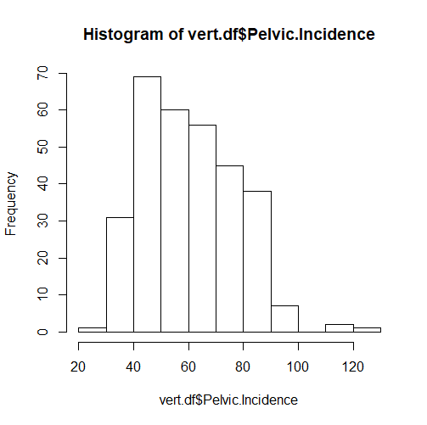**Pelvic Incidence:**

|  |
| --- |
| **Pelvic.Incidence** |
| Min. : 26.15 |
| 1st Qu.: 46.43 |
| Median : 58.69 |
| Mean : 60.50 |
| 3rd Qu.: 72.88 |
| Max. : 129.83 |

Figure 1: Histgram of Pelvic Incidence

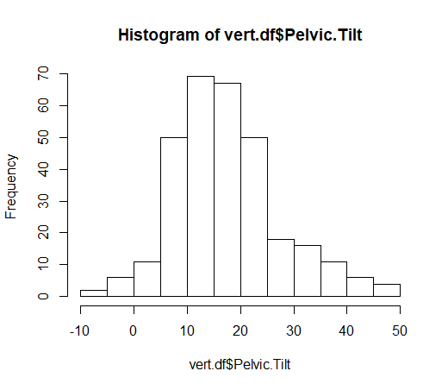**Pelvic Tilt:**

|  |
| --- |
| **Pelvic.Tilt** |
| Min. :-6.55 |
| 1st Qu.:10.67 |
| Median :16.36 |
| Mean :17.54 |
| 3rd Qu.:22.12 |
| Max. :49.43 |

Figure 2: Histogram of Pelvic Tilt

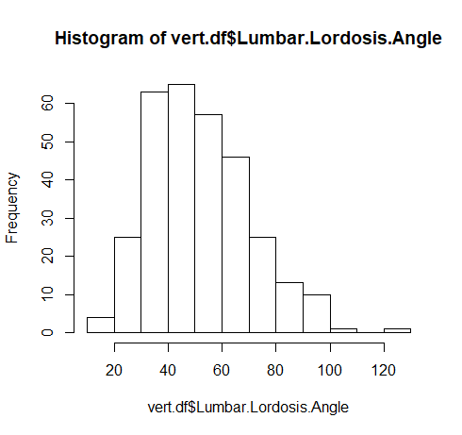

**Lumber Lordosis Angle:**

|  |
| --- |
| **Lumbar.Lordosis.Angle** |
| Min. : 14.00 |
| 1st Qu.: 37.00 |
| Median : 49.56 |
| Mean : 51.93 |
| 3rd Qu.: 63.00 |
| Max. : 125.74 |

**Sacral Slope**

Figure 3: Histogram of Lumber Lordosis Angle

|  |
| --- |
| **Sacral.Slope** |
| Min. : 13.37 |
| 1st Qu.: 33.35 |
| Median : 42.41 |
| Mean : 42.95 |
| 3rd Qu.: 52.69 |
| Max. : 121.43 |

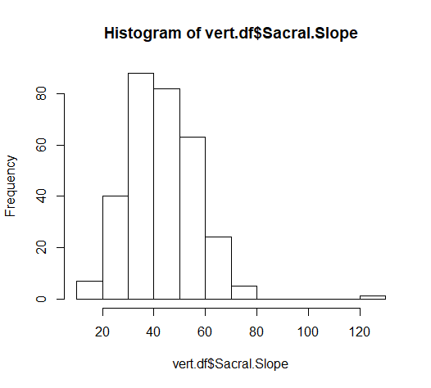

Figure 4: Histogram of Sacral Slope

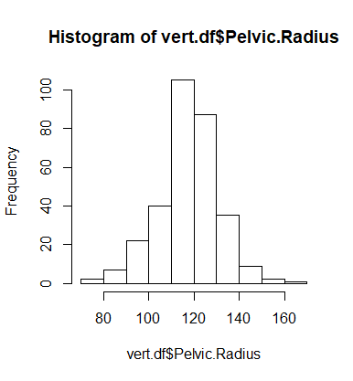**Pelvic Radius**

|  |
| --- |
| **Pelvic.Radius** |
| Min. : 70.08 |
| 1st Qu.:110.71 |
| Median :118.27 |
| Mean :117.92 |
| 3rd Qu.:125.47 |
| Max. :163.07 |

Figure 5: Histogram of Pelvic Radius

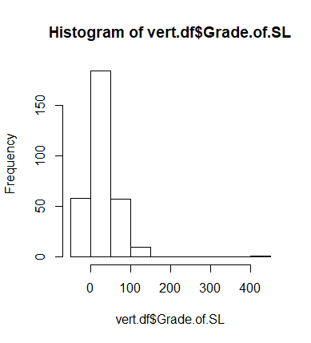

**Grade of spondylolisthesis (SL)**

|  |
| --- |
| **Grade.of.SL** |
| Min. :-11.06 |
| 1st Qu.:1.60 |
| Median :11.77 |
| Mean :26.30 |
| 3rd Qu.:41.28 |
| Max. :418.54 |

Figure 6: Histogram of Grade of Spondylolisthesis

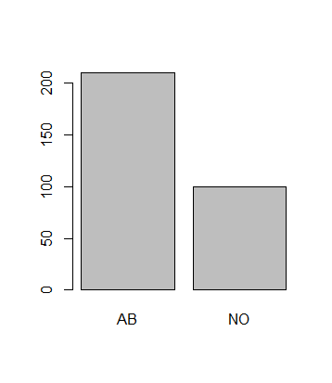**Decision**

|  |
| --- |
| **Decision** |
| AB:210 |
| NO:100 |

Figure 7: : Bar Plot of Dependent variable - Decision

**Graphs of each independent variable:**

|  |  |
| --- | --- |
| **Attribute: Pelvic Incidence:** | **Pelvic Tilt** |
| **Lumbar Lordosis Angle** | **Sacral Slope** |
| **Pelvic Radius** | **‘Grade of SL’ Attribute:** |

**Part: B**

This table can be built using linear and polynomial kernels with the codes attached.

10-fold cross validation is used.

Different Models building using the codes in R [File: ***linearKernel.R*** & ***polynomialKernel.R***]. while Cross validated Error calculation, 10 Fold Cross Validation is used in the Codes.

|  |  |  |  |  |
| --- | --- | --- | --- | --- |
| **ID** | **Kernel** | **Cost Constant** | **Training Error (%)** | **10 fold Cross-validated Error** |
| 1 | Linear | 0.001 | 32.25806 | 32.25806 |
| 2 | Linear | 0.01 | 28.3871 | 29.35484 |
| 3 | Linear | 0.1 | 13.22581 | 13.87097 |
| 4 | Linear | 1 | 15.16129 | 15.48387 |
| 5 | Linear | 10 | 13.87097 | 15.48387 |
| 6 | Linear | 100 | 13.54839 | 14.19355 |
| 7 | Linear | 1000 | 13.54839 | 14.83871 |
| 8 | Linear | 10000 | 13.54839 | 15.16129 |
| 9 | Polynomial, degree = 2 | 10 | 24.83871 | 30.64513 |
| 10 | Polynomial, degree = 2 | 100 | 23.22581 | 26.77419 |
| 11 | Polynomial, degree = 2 | 1000 | 25.16129 | 29.03226 |
| 12 | Polynomial, degree = 3 | 10 | 15.48387 | 19.03226 |
| 13 | Polynomial, degree = 3 | 100 | 13.22581 | 19.35484 |
| 14 | Polynomial, degree = 3 | 1000 | 10.96774 | 17.74194 |

It can be seen from the above table with linear kernel, increasing the complexity (cost, C) training error and cross validated errors are decreasing. Also, with polynomial kernel increasing the degree and cost increases the complexity; hence, reduces cross validated error.

Two best models are chosen considering the *complexity and cross validated errors* are:

|  |  |  |  |  |
| --- | --- | --- | --- | --- |
| **ID** | **Kernel** | **Cost Constant** | **Training Error (%)** | **10 fold Cross-validated Error** |
| 3 | Linear | 0.1 | 13.22581 | 13.87097 |
| 6 | Linear | 100 | 13.54839 | 14.19355 |

**Part C:**

AB = Abnormal and NO = Normal. If we consider AB = +1, and NO = -1 then,

The confusion matrix is for *ID: 3*

|  |  |  |  |
| --- | --- | --- | --- |
|  |  | **Predicted value** | |
| **Observed value** | | AB | NO |
| AB | | 195 | 15 |
| NO | | 26 | 74 |

The confusion matrix is for *ID: 6*

|  |  |  |  |  |
| --- | --- | --- | --- | --- |
|  |  | **Predicted value** | | |
| **Observed value** | | AB | NO |
| AB | | 189 | 21 |
| NO | | 21 | 79 |

1. It can be seen from the confusion matrix that, for model: 3, among 41 (26+15 = 41) errors 15 are the false negative errors, which is somehow balanced.

On the other hand, for model 6, among 42 (21+21 = 42) errors both false negative and false positive are same. So, it is neither balanced nor unbalanced.

1. Yes, model 3: kernel: linear, cost = 0.1 is preferable over model 6 because, in model 3 among 41 errors 15 s are false negative. Which is much less severe than model 6. In model 6 among 42 errors there are 21 s are false negative.

**Part D:**

Using the Bootstrap, hold-out method with my top two models and a 95% confidence interval, the lower and upper bound errors are given as follows:

|  |  |  |
| --- | --- | --- |
|  | **Lower Bound Error** | **Upper Bound Error** |
| **Model ID: 3 (Kernel = Linear, C = 0.1)** | 0.0753 | 0.2473 |
| **Model ID: 6 (Kernel = Linear, C = 100)** | 0.0753 | 0.2151 |

Code attached (File: **bootstrap.R**)

1. For a total of 1000 Bootstrap samples with the 95% error confidence interval, the lower bound is 2.5th percentile which is: 25th value of the corresponding error array and the upper bound is 97.5th percentile which is: 975th value of the corresponding error array.

For Model ID: 3, the 95% confidence interval is: **[0.0753, 0.2473].**

For Model ID: 6, the 95% confidence interval is: **[0.0753, 0.2151]**

1. Two models are: fD1 = [kernel = Linear, C = 0.1] with 95% confidence interval **[0.0753, 0.2473]**, Cross Validation Error (CVED1) = 0.1387 and fD2 = [kernel = Linear, C = 100] with the 95% confidence interval **[0.0753, 0.2151]**,Cross Validation Error (CVED1) = 0.1419.

we found: model 6’s confidence interval is completely overlapped with the model 3’s confidence interval. As a result, the performance of these two models are **not significantly** different.

To select the best models among these two, it is needed to see the other parameters besides Cross Validation Errors (CVE). So, **complexity** is considered here. As a result, model ID: 3 is which has Cost = 0.1 is much less complex than model ID: 6, which is Cost = 100. So, model ID: 3 ie. **fD1 = [kernel = Linear, C = 0.1]** is selected.

Moreover, model ID: 3 has the better performance of CVE than model ID: 6.